**Yr12 Integrated Science General 2020**

TASK 09: SIS

Physics – Factors affecting the severity of crashes

**Topic**

Newton’s Laws of Motion can be used to help determine the forces involved in car crashes.

For this investigation, you will be investigating how different variables affect the acceleration of an object on an angled ramp. Newton’s Second Law of Motion provides an exact relationship between force, mass and acceleration.

**F = ma**

We know that there are many different types of forces acting upon objects. The strength of these forces will affect the acceleration of the moving object and the force required to stop an object.

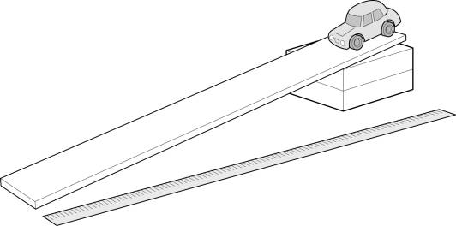

**Task**

Your task is to write a scientific report that details the findings of your investigation.

You may choose to investigate any of the following that are linked to Newton’s Laws of Motion, or any other experiment that adequately covers these laws:

* Relationship between friction and acceleration
* Relationship between ramp angle and acceleration
* Relationship between mass and acceleration
* How does acceleration affect the amount of force required to stop a vehicle?

**Task Detail**

Class allocated time: Term 2, Week 6 (4 lessons)

Task Due Date: Friday 12th June (Term 2, Week 7)

Weighting: 10%

**Useful Documents**

CoRE JBSC Investigation Report Guide (attached to assessment and seqta lessons)

**Unit Content Covered**

* identify, research and construct questions for investigation; propose hypotheses; and predict possible outcomes
* plan, select and use appropriate investigation methods, including pre-testing, to collect reliable data; assess risk and address ethical issues associated with these methods
* conduct investigations safely, competently and methodically for the collection of valid and reliable data
* represent data in meaningful and useful ways; organise and analyse data to identify trends, patterns and relationships; qualitatively describe sources of measurement error and use evidence to make and justify conclusions
* communicate scientific ideas and information for a particular purpose, using appropriate scientific language, conventions and representations
* the Laws of Motion can assist in predicting the motion of objects
* multiple forces can act on objects by direct contact, or from a distance, when the object is in motion

**Marking Rubric**

|  |  |  |
| --- | --- | --- |
| **Description** | **Marks Possible** | **Marks Received** |
| Title Page   * Relevant title for investigation that clearly and concisely details what the investigation is. | 1 |  |
| Table of Contents | 1 |  |
| Abstract   * Clearly describes the purpose and aim of the investigation. * Brief summary of the materials and method used. * Summary of results and conclusions. | 3 |  |
| Introduction   * Clearly introduces the purpose of the investigation. * Identify the aim of the investigation. * Formulates a testable hypothesis that clearly states the relationship between dependent and independent variables. * Background information (Newton’s Laws of motion, link to driving, describe the scientific concepts associated with investigation variables) | 6 |  |
| Variables   * Designs investigation to identify and control appropriate variables (independent, dependent, controls). | 3 |  |
| Method   * Describe the experimental method in detail, using labelled diagrams. | 5 |  |
| Results   * Accurately collect and organise data logically into a table, include relevant calculations. * Accurately graph data using correct conventions (ruler/pencil). | 6  6 |  |
| Discussion (see discussion points below)   * Comprehensively explain trends in the numerical/graphical data. * Communicate detailed information and concepts logically and coherently, using appropriate scientific language and conventions.   + Discuss how friction affects acceleration   + What affect does the mass of the object have on its acceleration   + Discuss how you could measure the effect of having a greater load in your car, compared to a normal load (assuming that you travelled at the same speed and distance) | 4  6 |  |
| Evaluation   * Provide relevant suggestions to improve the validity and reliability of the investigation. Discuss any limitations with the experiment. | 7 |  |
| Conclusion   * Summarise the investigation results and use evidence to draw conclusions that related to the hypothesis. | 3 |  |
| References   * Incorporate in-text referencing (where appropriate) and provide a reference list in correct format | 3 |  |
| Language Conventions   * Report to be written using concise language, in third person/past tense. | 3 |  |
| TOTAL MARKS | 57 |  |